PSALM 24:1 " The earth is the Lord's and the fullness thereof, the world and those who dwell therein."
There is an outstanding line in the movie, "Chariots of Fire" spoken by the protagonist, Olympic runner, and clergyperson, Eric Liddell. He speaks of the necessity of being "a muscular Christian.” Our faith is given to us to live in the real world as Jesus did live in the real world. And we in the Mason area have an opportunity in June to be those "muscular Christians."
On Saturday, June 25th, between 9:00 AM and Noon, the residents of Mason have the opportunity to bring hazardous household waste for safe disposal to the Wilton Recycling Center. Clean Harbors will be on site that day to coordinate proper disposal. For a complete listing of hazardous household items they will accept on that day go to: http://www.cleanharbors.com/browse_by_service/household_hazardous_waste/
The telephone number for the Wilton Recycling Center, should you have further questions is:
603-654-6150. The simplest and strongest thing about our Christian faith is the daily exercising of it. God bless you as we enter the Summer Season ! Pastor Veronica

PS Mason Conservation Committee provides special blue plastic bags for roadside trash collection which you can leave on the side of the road for town pickup. Pick up the blue bags at Charlie’s Auto Shop on Jackson Rd, or we will have a supply at church. Please put recyclable items into a separate bag you can take to the Wilton Recycling Center, or put them into our recycling bins in our church kitchen. Perhaps you can make a family project of collecting. Youngsters and teenagers have energy to spare and this could be an excellent neighborly project as well. If you have a neighbor who is unable to get rid of their hazardous products, perhaps you can offer a hand. Or, at least, you can offer a means of transportation.

Upcoming Events
- Bible Study with Pastor Veronica The last gathering for this series will be June 2, Thursday at 9:30 am.
- Father’s Day June 19th Remembering and honoring our fathers on this day in church and everywhere.
- Community Supper June 9th 5:30 – 7 pm Come for a meal, lively conversation, and the party atmosphere.

Coffee House June 18th Doors open at 6:30, Music starts 7pm Edward Thomas has a pleasant, gentle, in your face talent of telling you what’s up. The lyrics he chooses are straight ahead and so is his performance. The Living Room is thankful for the opportunity to close our 8th season with this talented singer song writer. As always, there are slots for open mic participants.
- Community News: Pipeline Meeting We are meeting June 6th, but may go to twice a month meetings to continue to work on current legislation to protect NH citizens. Call Kathy Chapman to check on a meeting 878-4993 or Michelle Scott 878-1680 http://nhpipelineawareness.org/ http://stopned.org

- Community Garden at Mason Church At about this time of year, we plant potatoes, tomatoes, Swiss chard, pole beans, and more which we will share with St Vincent DePaul Food Pantry, and our own gardenless members. Come help, enjoy the tending of the garden, and the broader mission of community. Contact Nancy Richards at 878-2190 or Betty Goen 878-2374
- Every day in our community, as in thousands of others, someone is struggling with illness or economic loss. Please help out by remembering to bring an item to put in the St. Vincent DePaul food pantry box in the hallway to Fellowship Hall. As we enjoy our Coffee Hour, we share our abundance. Thank you.
- Do you have an update for Church Directory: Send corrections or additions to miscott39@gmail.com Email Michelle if you would like a copy of this directory.
- Yarn into Prayer Shawls! Join the knitters of Mason Church in prayerful knitting. If you know someone who needs the warmth and prayers of a shawl please contact: Susan Suokko at Usercat2@comcast.net or 941-920-0270 or Michelle Scott 878-1680

- Curt Dunn and Karin Eisenhaure are both having challenges, but come to church and to other events as they value these connections, as we value their presence! What can we do to help? See what you can come up with.
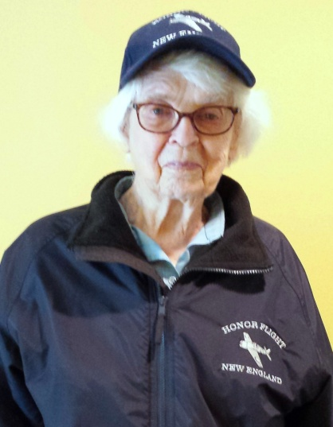
On May 19, Nancy Richards had a fabulous trip to DC to honor her, and other New England WW II Veterans for their service. She has photos and stories to share. She especially appreciated the ‘thank you Nancy’ cards that many of us turned in to Barbara Milkovits, who had been asked to solicit these from townspeople and family. The coordinator of the project presented the cards to Nancy as part of a special “mail call,” on their flight home.

- Joe and Jennie Walsh and Joshua, Jonathan and Joseph are always in our hearts and thoughts. Their address is: 50 Clinton Ave, Chelmsford, MA 01824 978-256-6700 Jwalsh131@comcast.net Joe has been hospitalized several times recently for a rare immune reaction. Please keep them in your prayers. See Jennie’s letter at church.
- Donna and Darrel Lawler A memorial service was held for Donna’s mother who died at the end of 2015. She lived a long, and fruitful life, and the family shared some of their many loving memories.

- Arthur Rafter is always in our thoughts. Arthur is now in Milford at Ledgewood Assisted Living.. His address is: 43 Ledgewood Dr. Milford, NH 03055 Ledgewood phone 672-5037
- Cindy Tibbetts Give Cindy, and her dog Rudy, a call at 809-2036 or 878-3904 to see if she needs a ride, some company, etc. Jim is retiring in June so Cindy will have him around more now! But there will still be plenty to do to help.
- Jean Randle is away in Nova Scotia for most of the month of June. It’s a wonderful time of year on the Canadian coast.
- Lilia Washburn She is always in our hearts, but I bet she would love to know it. Laila Washburn, c/o Brett Kivela, 25 Will Road, New Ipswich 03071. Although visitors are welcome from 10am to 7pm, it is good to call first. 878-3065
- Gretchen has limited mobility these days, and loves visitors. You can call ahead or stop by. Wally appreciates when food arrives with friends!
- Do you know someone who needs spiritual support or other support, of the pastor and deacons? Please call, your church family may be able to help. Leave a confidential message for the pastor at 603-878-1684 or on her personal phone at 213-6368. Any news items, comments, or things you would like to share: contact Michelle at 878-1680 or miscott39@gmail.com

